Ranoa, Julius

CSC 121 001 Computer Science I

August 31, 2017 Thursday

Homework.

Chapter 3. Programming Challenges on Page 149, Qn. 10. Box Office.

Screenshot of runtime:

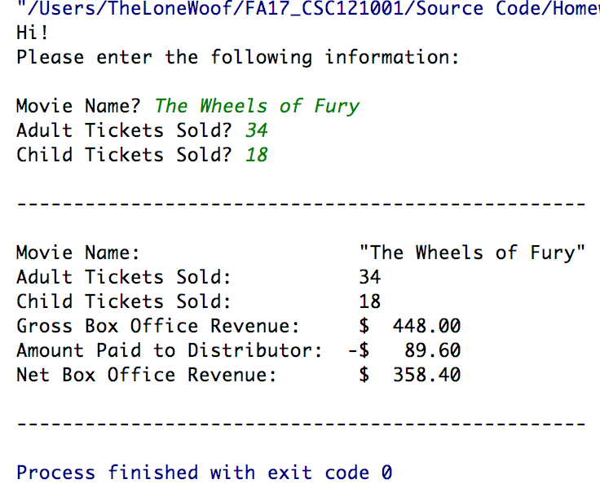

Files Included:

* main.cpp
* BoxOffice.h
* BoxOffice.cpp

Source Code:

* main.cpp
* BoxOffice.h  
  
* BoxOffice.cpp  
    
  *\* source code for BoxOffice.cpp continued on next page.*